Research paper 1

Network Science

University of Central Florida

**CNT 5805**

**1. Explain the difference of the following network science measurements by using a graph. The degree of a node, the degree of a graph, shortest path, the diameter of a network, clustering coefficient, inbetweenness, and Eigenvector.**

**Degree of a node**

Network Science provides many different ways to measure aspects of a network. When analyzing a network, the degree of a node can be found by counting the number of links connecting it to other nodes as seen in Figure 1. The first graph shows the black center node with a degree of 8 while the second graph shows a graph with a degree of 3. It’s also important to note that the examples provided are more centralized compared to other networks.

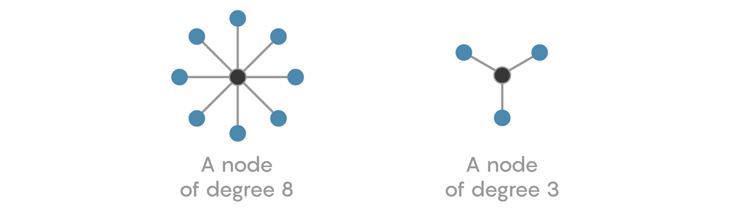**Figure 1. Degree of a Node**

[**https://www.quantamagazine.org/how-network-math-can-help-you-make-friends-20180820/**](https://www.quantamagazine.org/how-network-math-can-help-you-make-friends-20180820/)

**Degree of a network**

The degree of the entire network, on the other hand, is defined by the total number of edges between all the nodes in the network. Looking at the degree of a network shifts the focus from the individual node to all the nodes in the network and highlights the network’s distribution. The example below in Figure 2 shows a graph with a total of seven links therefore the degree of the graph is seven.

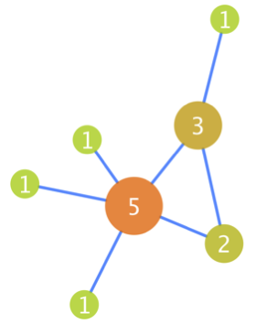

**Figure 2. Degree of a Network**

<https://www.ebi.ac.uk/training/online/course/network-analysis-protein-interaction-data-introduction/graph-theory-some-basic-definitions>

**Shortest path**

The shortest path is the shortest number of jumps it takes to go from one node to another. Tis the shortest count of edges between nodes.

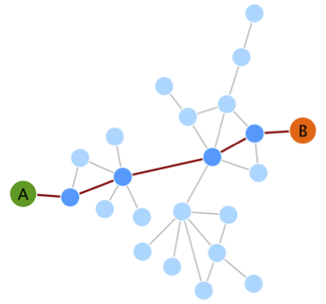

**Figure 3. Shortest Path**

<https://www.ebi.ac.uk/training/online/course/network-analysis-protein-interaction-data-introduction/graph-theory-some-basic-definitions>

**Diameter of a network**

Unlike the shortest path of a network, the diameter of a network is defined by the longest number of jumps between one end of a network and another. The diameter of a network can be found by finding all the shortest paths within a network and selecting the longest of the shortest paths. In Figure 4, the longest distance between any given node in the graphs provided is only three links.

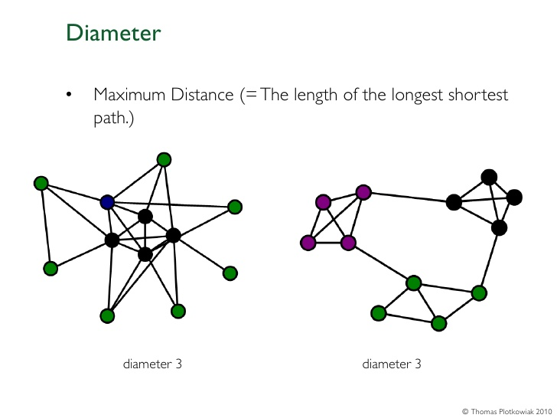

**Figure 4. Diameter of a Network**

<https://www.slideshare.net/plotti/social-network-analysis-intro-part-i>

**Clustering coefficient**

The clustering coefficient is the factor by which a graph’s tendency to cluster. A cluster within a network is defined as a triangle of nodes starting with one node connected to a second node which is connected to a third node and where the third node is connected to the first node. In the picture below, the graphs provided show what happens when there is a higher clustering coefficient within a graph. The higher the coefficient, the more likely the nodes are going to triangle and interconnect.

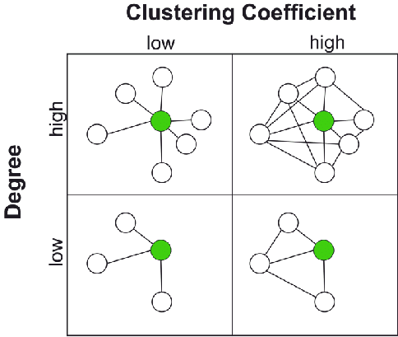

**Figure 5. Clustering Coefficient**

<https://www.researchgate.net/figure/Representation-of-the-clustering-coefficient-and-degree-Networks-have-nodes-with_fig5_261995698>

**Betweenness**

Betweenness refers to a node that acts as a bridge between node clusters. In the case below, Liz has high betweenness centrality because she is the only connection between the Allen and Lisa and the other clusters of friends.

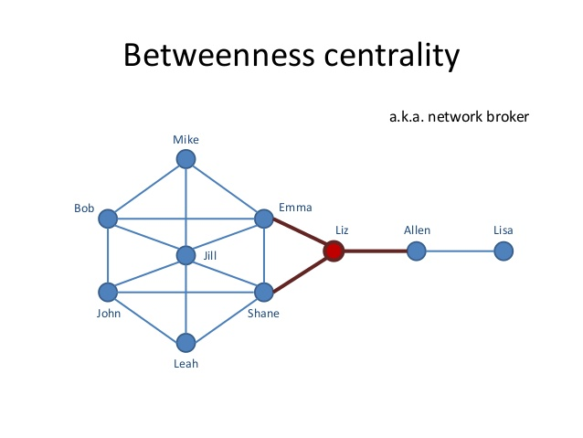

**Figure 6. Betweenness Centrality**

[**https://www.slideshare.net/dgasevic/learning-with-me-mate-analytics-of-social-networks-in-higher-education**](https://www.slideshare.net/dgasevic/learning-with-me-mate-analytics-of-social-networks-in-higher-education)

**Eigenvector**

Eigenvectors within networks can be described as a way to measure the amount of influence a node has within a network. Nodes with a higher eigenvector score tend to have more connections to other nodes with higher eigenvector scores. The popular phrase, “The rich get richer” is the embodiment of this concept.

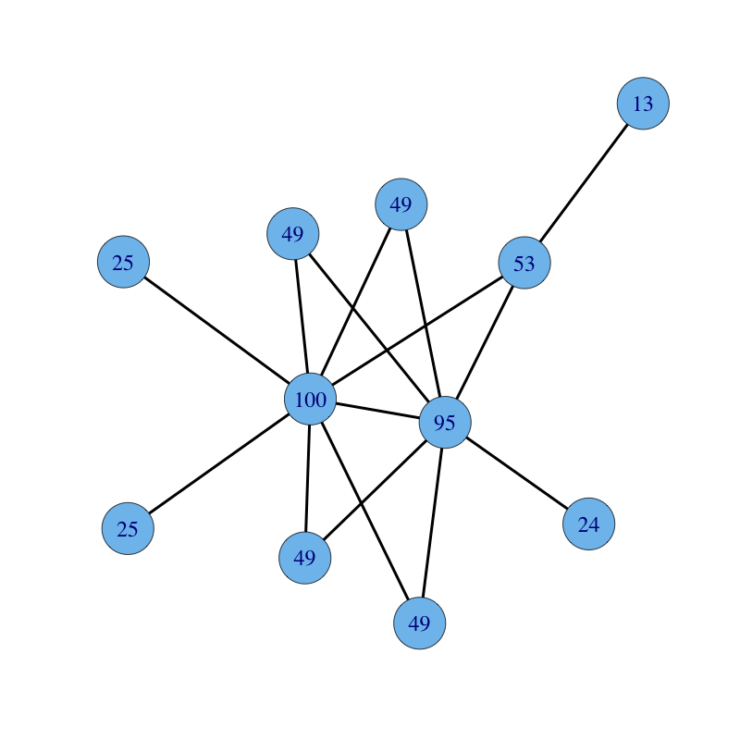

**Figure 7. Eigenvector**

[**https://www.sci.unich.it/~francesc/teaching/network/eigenvector.html**](https://www.sci.unich.it/~francesc/teaching/network/eigenvector.html)

**2. In general, describe what a bipartite network is and how it applied in network science. You may include a diagram to explain.**

Bipartite networks are networks that can be divided between two different sets of nodes with each set being independent from the other. An example could be a group of people and their favorite types of food. The people would be completely independent from each other but they might have similar interests in the type of food they eat which makes it easy for us to divide them into two separate foods. If we use the diagram pictured below, the U group would be the people and the V group would be the types of food.

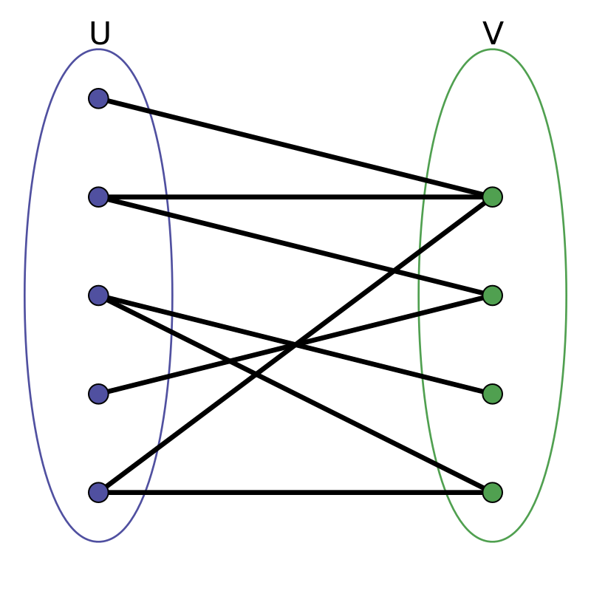

**Figure 8. Bipartite Network**

<https://commons.wikimedia.org/wiki/File:Simple-bipartite-graph.svg>

**3. Find a peer-reviewed research article in which bipartite network was used. Explain how the bipartite network was applied in this research.**

Bipartite networks can be applied to many forms of research depicting a simple A and B relationship. In 2011, a study was done to simulate the spread of sexually transmitted infections based on sex buyers and sex workers interacting online within higher-end prostitution. Majority of these transactions were sanctioned in online forums where buys and sellers would negotiate their terms and agree to a place to meet.

The study took into account both the network structure and the timeline of the epidemic. The bipartite network piece study was comprised of the sex buyers in one group while the other group comprised of the sex workers. The online relationships between the buyer and the sex workers represented the edges.

**4. What are Small Worlds? What characteristics do they have?**

Small Worlds are networks where the majority of the nodes are not neighboring one another, however, each node can be reached in a small number of jumps. Some of the characteristics include a preserved local network, a network diameter equal to the average shortest distance between two vertices and a logarithmical increase in the number of vertices (Amaral, L. A., Scala, A., Barthelemy, M., & Stanley, H. E., p. 11149).

**5. In 1973 Mark Granovetter wrote the most cited ever social network paper called “The Strength of Weak Ties” in the American Journal of Sociology. What does “The Strength of Weak Ties” mean and how relevant do you think the concept is today? Give a couple of examples.**

Everyone is a part of some type of complex network of our own family, friends and acquaintances. Our strongest relationships being our family and friends and our not-so-strong ones, being our acquaintances. We interact with our family and friends on a regular basis whether it be daily, weekly, bi-weekly, etc. but our acquaintances not so much. We might have talked to them here or there and maybe met them once before but your relationship has never been regular, however, there is still value there according to Mark Granovetter.

Mark Granovetter published an article in the American Journal of Sociology called, “The Strength of Weak Ties” in 1973. Granovetter pointed out a strange phenomena in which our most valuable interactions come from our weakest relationships. Since our most common interactions are with our closest relationships, these connections tend to overlap causing a disconnect from other social networks. Granovetter saw value in weak connections and encouraged interactions with our weak connections because these connections tend to transmit to other networks. These weaker connections have more betweenness centrality and act as a bridge to different networks.

This topic is often applied to job searching. When trying to apply for different jobs, the phrase, “It’s not what you know, it’s who you know” is often thrown around. This statement could not be more true when looking at Granovetter’s article. The job opportunities that appear before us do not tend to come from close friends or family but rather, acquaintances or friends of other friends. These connections tend to be people from other social and job networks that we are trying to get into. This situation is often highlighted by the other phrase, “Getting your foot in the door”.

Granovetter’s theory can also be applied to epidemiology. In another published article, Benedikt Köhler stated the importance of strong ties when dealing with the spread of disease. Stronger ties tend to share their connections within the group which would limit the possibility for the disease to spread or limit contact with the disease ( Köhler B, 2004, p. 10).

**Bibliography**

Question 1

* Eigenvector Centrality. (n.d.). Retrieved October 20, 2019, from https://www.sci.unich.it/~francesc/teaching/network/eigenvector.html.
* Gasevic, D. (2016, March 16). Learning with me Mate: Analytics of Social Networks in Higher Educati... Retrieved October 20, 2019, from https://www.slideshare.net/dgasevic/learning-with-me-mate-analytics-of-social-networks-in-higher-education.
* Graph theory: network topology. (2016, December 5). Retrieved October 20, 2019, from https://www.ebi.ac.uk/training/online/course/network-analysis-protein-interaction-data-introduction/graph-theory-some-basic-definitions.
* Honner, P., & Quanta Magazine. (2018, August 20). How Network Math Can Help You Make Friends. Retrieved October 20, 2019, from https://www.quantamagazine.org/how-network-math-can-help-you-make-friends-20180820/.
* Plotkowiak, T. H. (2012, April 18). Social network analysis intro part I. Retrieved October 20, 2019, from https://www.slideshare.net/plotti/social-network-analysis-intro-part-i.
* Rocha, L. E. C., Liljeros, F., & Holme, P. (2011, March 17). Simulated Epidemics in an Empirical Spatiotemporal Network of 50,185 Sexual Contacts. Retrieved October 15, 2019, from https://journals.plos.org/ploscompbiol/article?id=10.1371/journal.pcbi.1001109.

Question 2

* File:Simple-bipartite-graph.svg. (n.d.). Retrieved October 20, 2019, from https://commons.wikimedia.org/wiki/File:Simple-bipartite-graph.svg.

Question 3

* Rocha, L. E. C., Liljeros, F., & Holme, P. (2011, March 17). Simulated Epidemics in an Empirical Spatiotemporal Network of 50,185 Sexual Contacts. Retrieved October 15, 2019, from https://journals.plos.org/ploscompbiol/article?id=10.1371/journal.pcbi.1001109.

Question 4

* Amaral, L. A., Scala, A., Barthelemy, M., & Stanley, H. E. (2000, October 10). Classes of small-world networks. Retrieved October 20, 2019, from https://www.ncbi.nlm.nih.gov/pmc/articles/PMC17168/.

Question 5

* Granovetter, Mark S. 1973. The Strength of Weak Ties. American Journal of Sociology 78:1360-1380.
* Köhler B. 2004. Weak ties, modern epidemics, and world society. Connections 26, 9-10. Retrieved September 1, 2005 from http://www.insna.org/Connections-Web/Volume26- 1/2.Kohler.pdf